Assignment 7: Transitive Functional Dependency, Compound PK and Table Decomposition

**User**(user_id, user_name, user_username, user_passsword)

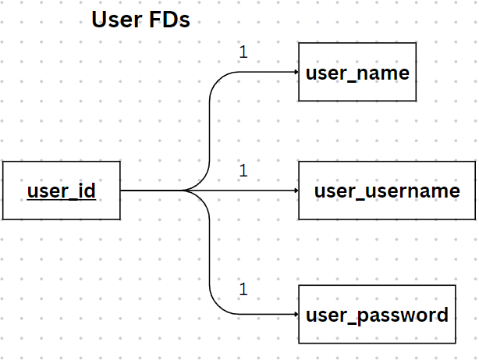

FD = {

1. user_id → user_name, user_username, user_password

}

**Admins**(admin_id, admin_username, admin_password)

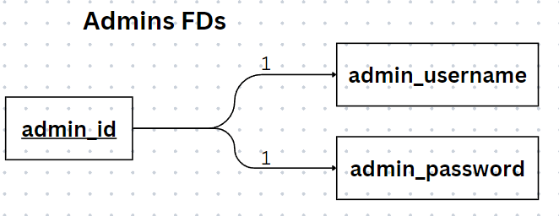

FD = {

1. admin_id → admin_username, admin_password

}

**Items**(item_id, item_name, item_description, item_minBid, item_startDate, item_endDate, item_buyPrice)

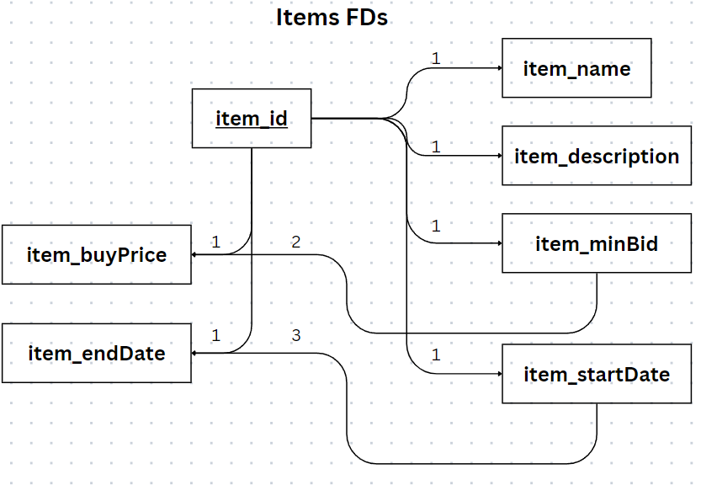

FD = {

1. item_id → item_name, item_description, item_minBid, item_buyPrice, item_startDate, item_endDate
2. item_minBid → item_buyPrice
3. item_startDate → item_endDate

}

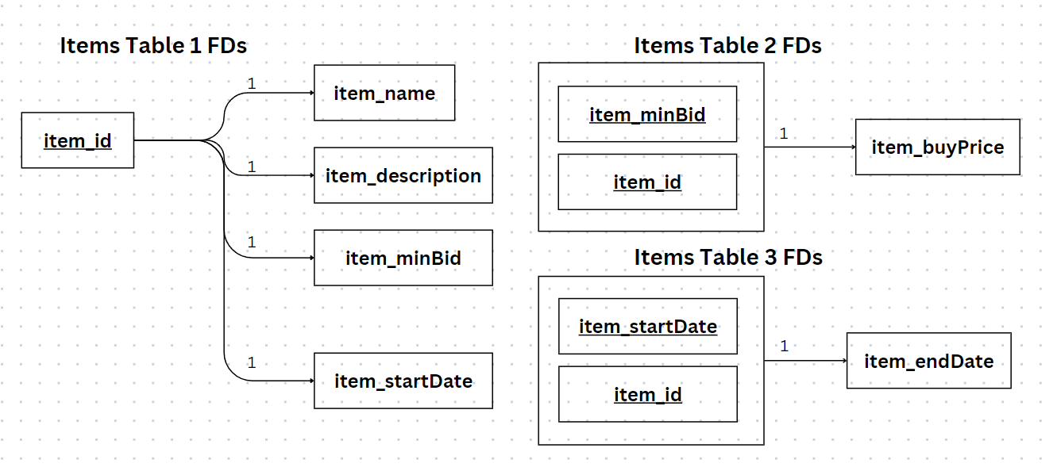

**Auctions**(auction_id, user_id, item_id, auction_latest)

1NF and Transitive and Compound

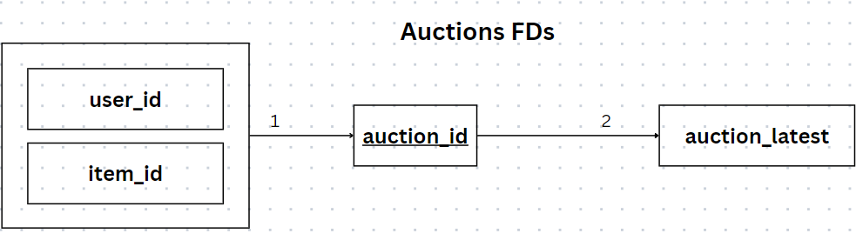

FD = {

1. user_id, item_id → auction_id
2. auction_id → auction_latest

}

Decomposition from Compound FD -> 2NF

Decomposition from Transitive FD -> 3NF

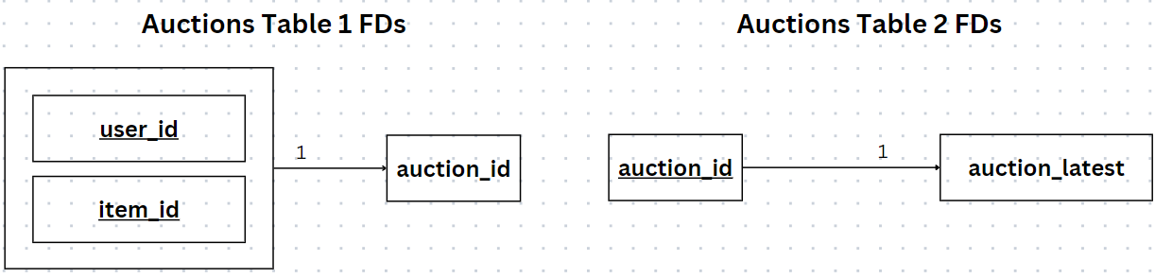

**Finance**(finance_number, user_id, finance_expiry, finance_address, finance_cvv)

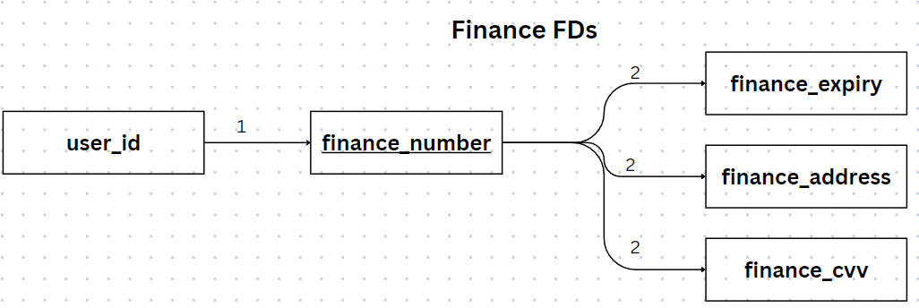

FD = {

1. user_id → finance_number
2. finance_number → finance_expiry, finance_address, finance_cvv

}

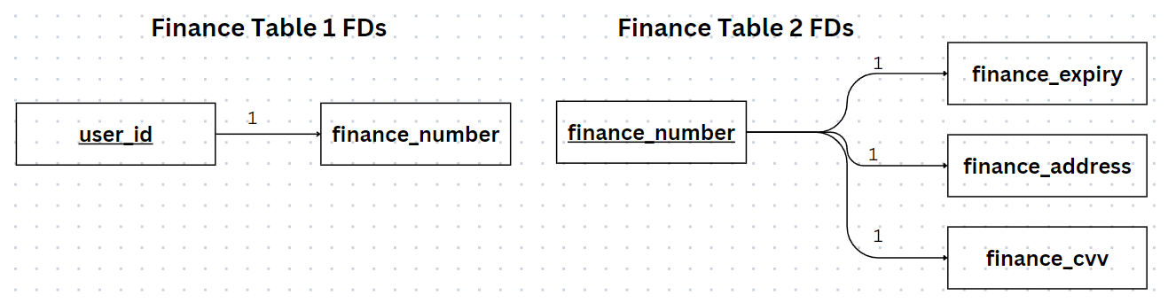

**Shipping**(user_id, shipping_receiver, shipping_tracking)

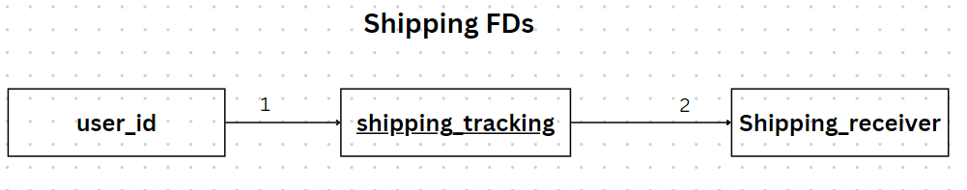

FD = {

1. user_id → shipping_tracking
2. shipping_tracking → shipping_receiver

}

Decomposition from Compound FD -> 2NF

Decomposition from Transitive FD -> 3NF

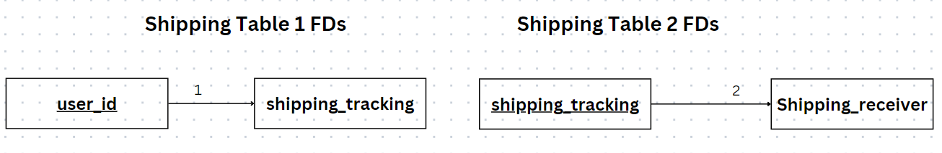

**Bids**(bid_id, item_id, user_id, bids_top)

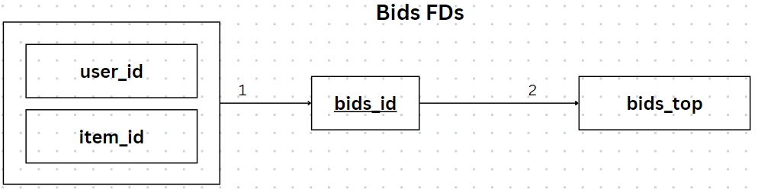

FD = {

1. user_id, item_id → bids_id
2. bids_id → bids_top

}

Decomposition from Compound FD -> 2NF

Decomposition from Transitive FD -> 3NF

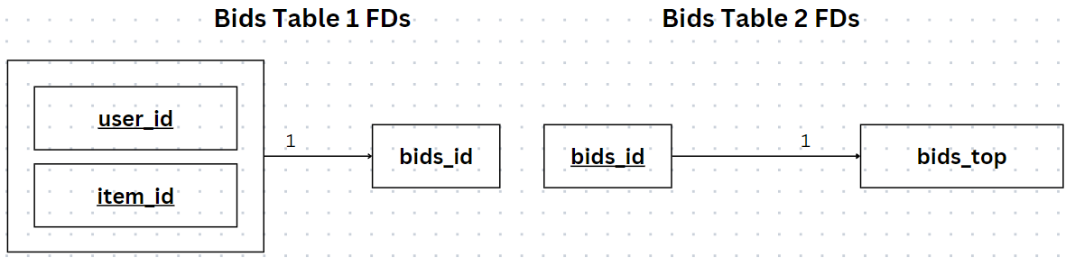

**pastbids**(pastbids_id, item_id, user_id, pastbid_bidDate, pastbid_bid)

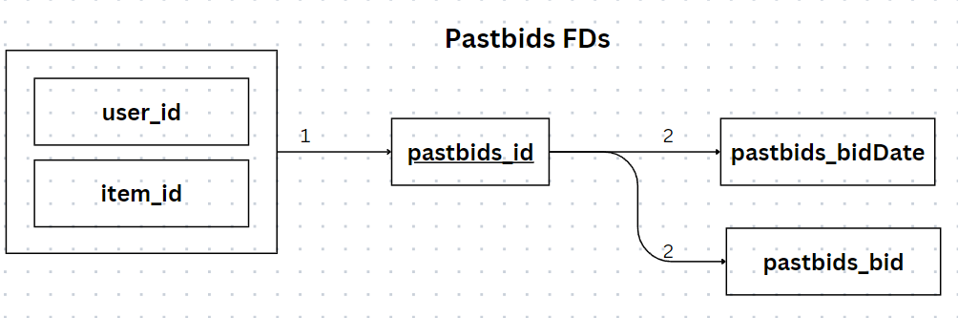

FD = {

1. user_id, item_id → pastbids_id
2. pastbids_id → pastbids_bidDate, pastbids_bid

}

